UNIT 5

Q1**) Explain following terms: i) Groups ii) Rings iii) Prime numbers**   
i) Groups:   
A group G is a nonempty set together with a binary operation (*) such that the following three properties are satisfied:   
1. Associativity: (a*b)*c = a*(b*c). For all a, b, c e G.   
2. Identity: There is an element e & G such that a*e = e*a. For all a ε G.   
3. Inverses: For each element a & G, there is an element be G such that a*b b*a = e.

ii) Rings:   
A Ring R is a nonempty set with two binary operations, addition (denoted by a + b) and multiplication (denoted ab), such that for all a, b, c ɛ R:

1. R is an abelian group under addition.

2. a(bc)= (ab)c (associativity)

3. a(b+c) = ab + ac and (b+c)a = bc + ca.

A Unity in a ring is a nonzero element that is the identity under multiplication.  
A Commutative Ring R is ring such that for all a, b, c, ɛ R.   
1. a(b + c) = ab + ac = (b + c) a (commutativity)

A Unit is a nonzero element of a Commutative Ring with Unity that has a multiplicative inverse.   
A Zero-Divisor is a nonzero element a ɛ R, R is a commutative ring, such that there is a nonzero element bɛR with ab = 0.   
An Integral Domain is a commutative Ring with unity and no zero-divisors.

iii) Prime Numbers: Every number can be factorized into its prime numbers. Generally, it's very hard to find the factors of a number. To find all the prime factors of a natural number n, one has to try and divide it by its possible factors up to √2. It is very difficult to find the prime factors of large number. RSA uses prime number.  
--------------------------------------------------------------------------------------------------------------------------------------------------------------------------------  
q2) **short notes on Encryption and Decryption  
i) Encryption**  
Encryption is a fundamental process in cybersecurity that transforms readable data, known as **plaintext**, into an unreadable format called **ciphertext**. This conversion is achieved using a mathematical algorithm and a secret value known as an **encryption key**. The primary purpose of encryption is to ensure the confidentiality of data, making it unintelligible to unauthorized individuals even if they gain access to it.

Encryption is crucial for protecting sensitive information in various scenarios, including data stored on devices (data at rest), data transmitted over networks (data in transit), and even data while it is being processed. There are two main types of encryption:

* **Symmetric Encryption:** Uses the same secret key for both encryption and decryption. This method is generally faster but requires secure key exchange between the communicating parties.
* **Asymmetric Encryption (Public-Key Encryption):** Uses a pair of mathematically linked keys: a public key for encryption and a private key for decryption. The public key can be freely distributed, while the private key 1 is kept secret by the recipient. This method is more secure for key distribution but computationally more intensive.

**Example:**If the plaintext is HELLO, encryption might transform it into something like XMCKL.

**ii) Decryption**

Decryption is the reverse process of encryption. It is the method of converting encrypted data (**ciphertext**) back into its original readable form (**plaintext**). This process requires the use of a specific **decryption key** and the appropriate algorithm that was used during the encryption process.

The decryption key corresponds to the encryption key. In symmetric encryption, the same key is used for both encryption and decryption. In asymmetric encryption, the private key is used to decrypt data that was encrypted with the corresponding public key.

Decryption is necessary for authorized recipients to access and understand the information that was encrypted for their eyes only. It is a critical step in ensuring the usability of protected data while maintaining its security during transmission or storage. Without the correct decryption key, the ciphertext remains effectively meaningless and inaccessible. Decryption allows for secure communication, access to encrypted stored data, and is a vital component in maintaining data privacy and integrity.

**Example:**The ciphertext XMCKL is decrypted back to the original message HELLO.  
--------------------------------------------------------------------------------------------------------------------------------------------------------------------------------  
Q3) Explain following terms. i) Cryptography , ii) Symmetric key cryptography , iii) Asymmetric key cryptography

i**) Cryptography**   
The original intelligible message, referred to as plaintext is converted into random nonsense, referred to as ciphertext. The science and art of manipulating messages to make them secure is called cryptography.   
An original message to be transformed is called the plaintext, and the resulting message after the transformation is called the ciphertext.   
The process of converting the plaintext into ciphertext is called encryption. The reverse process is called decryption. The encryption process consists of an algorithm and a key. The key controls the algorithm.   
The objective is to design an encryption technique so that it would be very difficult or impossible for an unauthorized party to understand the contents of the ciphertext.   
The primary goals of modern cryptography extend beyond just confidentiality to include:

* **Confidentiality:** Ensuring that information is accessible only to authorized individuals.
* **Integrity:** Guaranteeing that information has not been altered or tampered with during transit or storage.
* **Authentication:** Verifying the identity of the communicating parties or the origin of the information.
* **Non-repudiation:** Preventing a sender from denying having sent a message or a receiver from denying having received it.

ii) **Symmetric key cryptography:**   
A symmetric encryption model has five ingredients.   
1. Plaintext   
2. Encryption algorithm   
3. Secret key   
4. Ciphertext   
5. Decryption algorithm

Fig. Q.4.1 shows the conventional encryption model.   
 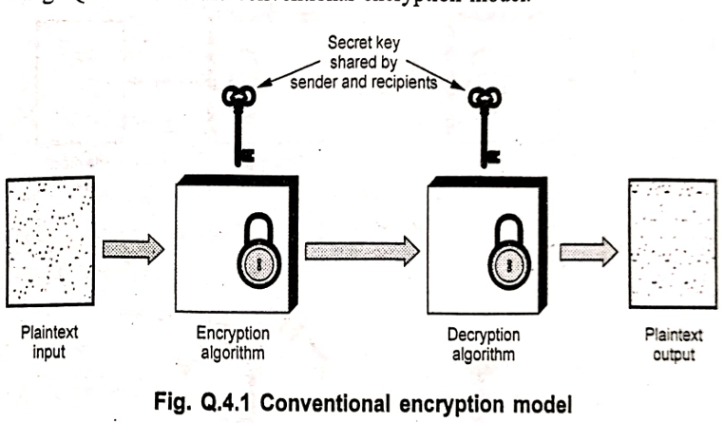

**Plaintex**t is the original message or data that is fed into the algorithm as input.   
**Encryption** algorithm performs various substitutions and transformations on the plaintext.   
**Secret key** is a value independent of the plaintext and of the algorithm. The exact substitutions and transformations performed by the algorithm depend on the key.   
**Ciphertext** is the scrambled message produced as output. It depends on the plaintext and the secret key.   
**Decryption** algorithm takes the ciphertext and the secret key and produces the original plaintext.

**iii) Asymmetric key cryptography:**A public key encryption scheme has six ingredients. Fig. Q.4.2 shows public key cryptography.

(a) Encryption   
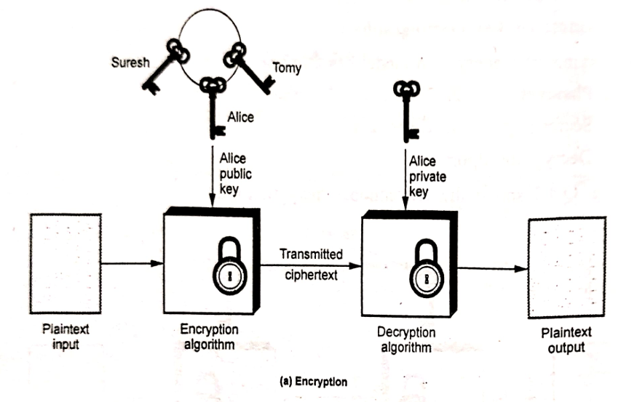

Fig. Q.4.2 Public key cryptography  
1. Plaintext: It is input to algorithm and in a readable message or data.   
2. Encryption algorithm It performs various transformations on the plaintext.   
3. Public and private keys: One key is used for encryption and other is used for decryption.   
4. Ciphertext: This is the scrambled message produced as output. It depends on the plaintext and the key.   
5. Decryption algorithm: This algorithm accepts the ciphertext and the matching key and produces the original plaintext.

The essential steps are the following:   
1. Each user generates a pair of keys to be used for the encryption and decryption of messages.   
2. Each user places one of the two keys in a public register. This is the public key. The companion key is kept private.   
3. If Bob wishes to send a confidential message to Alice, Bob encrypts the message using Alice's public key.   
4. Alice decrypts the message using her private key  
--------------------------------------------------------------------------------------------------------------------------------------------------------------------------------  
Q4) **Data Encryption Standard (DES)**Data Encryption Standard (DES) is a symmetric block cipher. By ‘symmetric’, we mean that the size of input text and output text (ciphertext) is same (64-bits). The ‘block’ here means that it takes group of bits together as input instead of encrypting the text bit by bit. Data encryption standard (DES) has been found vulnerable to very powerful attacks and therefore, it was replaced by Advanced Encryption Standard (AES).

* It is a block cipher that encrypts data in 64 bit blocks.
* It takes a 64-bit plaintext input and generates a corresponding 64-bit ciphertext output.
* The main key length is 64-bit which is transformed into 56-bits by skipping every 8th bit in the key.
* It encrypts the text in 16 rounds where each round uses 48-bit subkey.
* This 48-bit subkey is generated from the 56-bit effective key.
* The same algorithm and key are used for both encryption and decryption with minor changes.

Q5) **RSA Algorithm**

RSA is a block cipher in which the plaintext and ciphertext are integers between 0 and n - 1 for some n.   
A typical size for n is 1024 bits.   
The RSA algorithm developed in 1977 by Rivest, Shamir, Adleman (RSA) at MIT. RSA algorithm is public key encryption type algorithm. In this algorithm, one user uses a public key and other user uses a secret (private key) key.   
In the RSA algorithm each station independently and randomly chooses two large primes p and q number, and multiplies them to produce n = pq which is the modulus used in the arithmetic calculations of the algorithm.

The details of the RSA algorithm are described as follows:   
Key generation :   
1) Pick two large prime numbers p and q, p ne q;   
2) Calculate n = pq   
3) Calculate phi(n) = (p - 1)(q - 1)   
4) Pick e, so that gcd (e, phi(n) = 1 1<e dot < phi(n)   
5) Calculate d, so that de mod phi(n) = 1 i.e. d is the multiplicative inverse of e in mod phi(n)   
6) Get public key as KU = {e, n}   
7) Get private key as KR = {d, n}

Encryption:   
For plaintext block P < n its ciphertext C = P ^ e mod n.

Decryption :   
For ciphertext block C, its plaintext is P = C ^ d mod n.

**Why RSA works :**As we have seen from the RSA design, RSA algorithm uses modular exponentiation operation. For exponential inverse in mod n. n = pq e which is relatively prime to Phi(n) has   
Its exponential inverse d can be calculated as the multiplicative inverse of e in mod phi(n) The reason is illustrated as follows:   
Based on Euler's theorem, for y which satisfies y mod phi(n) = 1 the following equation holds :

x ^ y mod n = x mod n

AS de mod phi(n) = 1 we have that cryptosystem is shown as follows: Ped = P mod n. So the correctness of RSA   
Encryption: C = P ^ e mod n;   
Decryption: : P = C ^ d mod n = (Pe)d mod n = Ped mod n = P mod n = P

**Why RSA is secure:**The premise behind RSA's security is the assumption that factoring (n into P and q) is hard. And thus it is difficult to determine (n) Without the knowledge of o(n) it would be hard to derive d based on the knowledge of e. a big number

**Advantages**1. RSA can be used both for encryption as well as for digital signatures. 2. Trapdoor in RSA is in knowing value of n but not knowing the primes that are factors of n.

**Disadvantages**1. If any one of P, q, m, d is known, then the other values can be calculated. So secrecy is important. 2. To protect the encryption, the minimum number of bits in n should be 2048.

**Attacks on RSA**1. Brute force: This involves trying all possible private keys. 2. Mathematical attacks: This involves the factoring the product of two primes. 3. Timing attacks: These depends on the running time of the description algorithm. 4. Chosen ciphertext attacks: This type of attack exploits properties of the RSA algorithm.  
---------------------------------------------------------------**-----------------------------------------------------------------------------------------------------------------  
q6) what a digital signature is and its applications**A digital signature is an **authentication mechanism** that allows the creator of a message to attach a code that acts as a signature. This signature is formed by taking the **hash of the message** and **encrypting the message with the creator's private key**.     
In simpler terms, a digital signature is a cryptographic technique used to verify the authenticity and integrity of a digital message or document. It provides assurance to the recipient that the message originated from the claimed sender (authentication) and that it has not been altered since it was signed (integrity).

**How a Digital Signature is Created (Based on the text):**  
1. A **hash** of the original message is calculated. A hash is a fixed-size string of characters that is unique to the message. Any change in the message will result in a different hash value.  
2. The calculated hash value is then **encrypted using the sender's private key**. This encrypted hash is the digital signature.  
3. The digital signature is attached to the original message.

The text mentions that there are public parameters involved, including prime numbers and other values, which are used in the key generation process for the public and private keys. The creation of the signature also involves the user's private key, the hash code of the message, and an additional integer.

**How a Digital Signature is Verified (Based on the text):**  
At the receiving end, the verifier performs a process to validate the digital signature:

1. The receiver uses the sender's **public key** (which is mathematically linked to the sender's private key used for signing) and the received digital signature.
2. Using the decryption capability of the public key on the digital signature, the receiver recovers the original hash value of the message that the sender had encrypted.
3. The receiver independently calculates a hash of the received message.
4. The receiver compares the calculated hash value with the hash value recovered from the digital signature.

If the two hash values match, the signature is considered **validated**. This confirms that the message has not been altered since it was signed by the holder of the private key. The text also mentions that the verification process involves generating a quantity based on public key components, the sender's public key, and the hash code of the incoming message, and comparing this quantity to components of the signature.

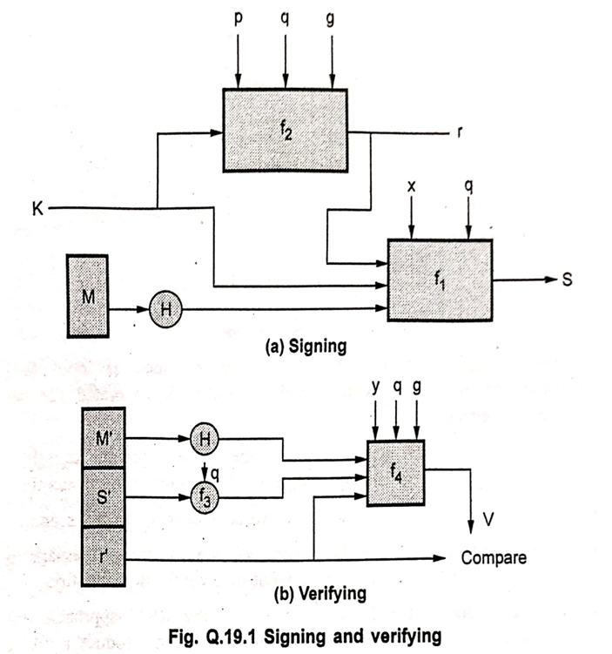  
**applications of digital signatures in different sectors:  
1. Financial sectors:** Digital signatures are used in various financial processes, including:MortgagesInsurance documentationLoan processingPaperless bankingContracts **2. Manufacturing industries:** Digital signatures are utilized in manufacturing to enhance and streamline processes such as:Manufacturing enhancementsQuality Assurance (QA)Product designSales and marketing **3. Cryptocurrencies:** Digital signatures play a crucial role in the security of cryptocurrencies. They use asymmetric cryptography to help prove the legitimate owner of the crypto, such as Bitcoin, addressing the security concerns related to hacking in this domain.  
---------------------------------------------------------------**-----------------------------------------------------------------------------------------------------------------  
q7) Diffie-Hellman Key Exchange**The Diffie-Hellman key exchange protocol is a cryptographic method developed by Diffie and Hellman in 1976. Its primary purpose is to allow two parties to **exchange a secret key over an insecure medium without any prior shared secrets**. This is a significant achievement as it enables secure communication to be established even when the communicating parties have no existing secure channel to agree upon a secret key beforehand.The protocol is based on the mathematical properties of modular exponentiation and the difficulty of solving the discrete logarithm problem.

**Parameters:**  
The protocol uses two publicly known parameters:

* **p:** A large prime number.
* **g:** An integer that is a primitive root modulo p. This means that for every number n between 1 and p-1, there is a power of g such that g^k mod p = n for some integer k.

These parameters (p and g) are public and can be common to a group of users.

**Key Exchange Process:** Suppose Alice and Bob want to agree on a shared secret key using the Diffie-Hellman protocol:  
1. **Alice and Bob choose private values:**  
Alice selects a random private integer value, let's call it 'a'.  
Bob selects a random private integer value, let's call it 'b'.  
Both 'a' and 'b' are kept secret by Alice and Bob, respectively. These private values must be numbers from 1 to (p-1) and should be chosen randomly or pseudorandomly.  
2. **Alice and Bob compute their public values:**  
Alice computes her public value, let's call it YA, using the formula: YA = g^a mod p.  
Bob computes his public value, let's call it YB, using the formula: YB = g^b mod p.  
3. **Exchange Public Values:**  
Alice sends her public value (YA) to Bob over the insecure channel.  
Bob sends his public value (YB) to Alice over the insecure channel.  
4. **Compute the Shared Secret Key:**  
Alice receives Bob's public value (YB). She computes the shared secret key (K) using her private value ('a') and Bob's public value (YB): K = (YB)^a mod p. Substituting YB = g^b mod p, Alice computes K = (g^b mod p)^a mod p = g^(b*a) mod p = g^(ab) mod p.

Bob receives Alice's public value (YA). He computes the shared secret key (K) using his private value ('b') and Alice's public value (YA): K = (YA)^b mod p. Substituting YA = g^a mod p, Bob computes K = (g^a mod p)^b mod p = g^(a*b) mod p = g^(ab) mod p.

As you can see, both Alice and Bob arrive at the same shared secret key, K = g^(ab) mod p. This key can then be used for symmetric encryption to secure their subsequent communication.

**Algorithm:**

Select two numbers (1) prime number q (2) a an integer that is a primitive root of q.   
Suppose the users A and B wish to exchange a key.   
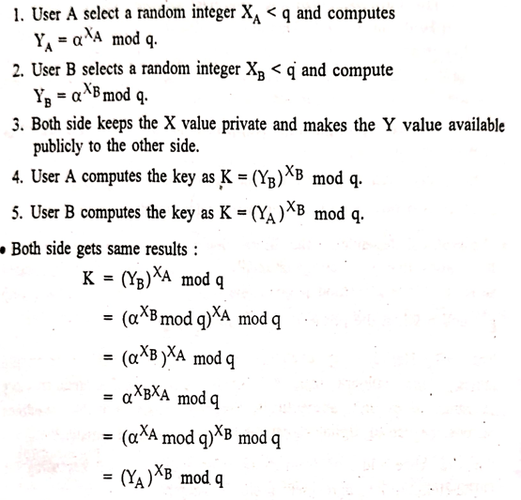  
---------------------------------------------------------------**-----------------------------------------------------------------------------------------------------------------  
q8) 🔐 PKIX Model (Public Key Infrastructure X.509)**

**PKIX (Public Key Infrastructure X.509)** is a standard developed by the **IETF (Internet Engineering Task Force)** that defines how to use **X.509 certificates** in a Public Key Infrastructure (PKI).  
**🔧 Components of the PKIX Model:**  
1. **End Entity (User or Application)**: The certificate user: This could be a person, software, or hardware device that requires a public-key certificate.  
2. **Certificate Authority (CA)**  
The trusted third party that issues and signs certificates.  
Ensures identity verification before issuance.  
3. **Registration Authority (RA)**  
Acts as a verifier of the user’s identity on behalf of the CA.  
It **does not issue certificates** but forwards requests to the CA.  
4. **Certificate Repository**: A centralized directory (like LDAP) that stores and distributes certificates and **Certificate Revocation Lists (CRLs)**.  
5. **CRL Issuer** : Issues certificate revocation lists indicating certificates that are no longer valid.

**🔁 PKIX Certification Path:  
1.** The **end user** submits a certificate request to the **RA**. **2.** The **RA verifies** the identity and forwards it to the **CA**. **3.** The **CA issues** the certificate and stores it in the **certificate repository**. **4.** Other users can retrieve this certificate to verify identity.  
5. The **CRL Issuer** publishes a list of revoked certificates regularly.

**Public Key Distribution Approaches**

Four primary methods for distributing public keys are discussed:

* **Public Announcement:** In this approach, any participant in a public key algorithm can openly send or broadcast their public key to the community. The document notes that due to the popularity of PGP, many users append their public keys to messages sent to public forums, such as USENET newsgroups and Internet mailing lists.
* **Publicly Available Directory:** This method enhances security by utilizing a publicly available, dynamic directory for public keys. A trusted entity or organization is responsible for maintaining and distributing this directory.
* **Public Key Authority:** This involves a user obtaining a third party's assistance for key distribution.
* **Public Key Certificates:** Participants can exchange keys using certificates provided by a public key authority. A certificate comprises a public key and an identifier of the key's owner, all signed by a trusted third party. A certificate authority, such as a government agency or financial institution trusted by the community, serves as this third party. A user can securely present their public key to the authority, obtain a certificate, and then publish it.

**Public Key Infrastructure (PKI)**  
PKI is presented as a well-known technology for establishing identities, encrypting information, and digitally signing documents. It identifies and manages relationships between parties in electronic exchanges, addressing various security needs including access control, confidentiality, integrity, authentication, and non-repudiation. PKI utilizes digital certificates to secure e-commerce, email, data exchange, and VPNs, and to verify user identities and privileges.

The Certificate Authority (CA) plays a crucial role in PKI by providing full lifecycle management of public keys and certificates, including issuance, authentication, storage, retrieval, backup, recovery, updating, and revocation. All PKI users are expected to have a registered identity stored in a digital certificate issued by a CA. Remote users and sites employing public keys and certificates can authenticate each other with high confidence, provided three conditions are met for authentication:

1. The private key has not been stolen or copied from the owner.
2. The certificate was issued according to the stated policy of the certificate issuer.
3. The policies of the certificate issuer are satisfactory to the parties involved for identity verification.

**Benefits of PKI**  
The document lists four key benefits of PKI:  
1. **Confidential Communication:** Ensures that only intended recipients can read files.  
2. **Data Integrity:** Guarantees that files remain unaltered during transmission.  
3. **Authentication:** Verifies the claimed identities of involved parties.  
4. **Non-repudiation:** Prevents individuals from denying their actions.

**Limitations of PKI**  
The problems encountered when deploying a PKI are categorized as follows:  
1. Public key infrastructure is new.  
2. Lack of standards.  
3. Shortage of trained personnel.  
4. Public key infrastructure is mostly about policies.  
---------------------------------------------------------------**-----------------------------------------------------------------------------------------------------------------  
q9) Hash Function**

A hash function is a mathematical algorithm that takes an input (or 'message') and returns a fixed-size string of bytes. This string is called a 'hash value', 'hash code', 'digest', or 'fingerprint'.

Key characteristics of a cryptographic hash function include:

* Deterministic: The same input will always produce the same output hash value.
* One-way: It is computationally infeasible to reverse the hash function; that is, to determine the original input from the hash value alone.
* Collision Resistant: It is computationally infeasible to find two different inputs that produce the same hash output.

Hash functions are widely used in cryptography for various purposes, including verifying data integrity, digital signatures, and password storage. By comparing the hash of a file before and after transmission or storage, one can determine if the file has been altered.

---------------------------------------------------------------**-----------------------------------------------------------------------------------------------------------------**

**Q10) digital certificate**   
A digital certificate is a digital data structure that securely links an individual or entity to a public key. It's a crucial component in cryptographic operations like digital signatures and asymmetric encryption, essentially serving as an electronic ID card issued by a trusted third party known as a Certification Authority (CA).

To obtain a digital certificate, an organization applies to a CA, which is responsible for validating and ensuring the authenticity of the requesting entity. The certificate itself contains key information including the name of the organization, a serial number, the validity date, the organization's public key, and the digital signature of the CA. This digital signature allows recipients to confirm the authenticity of the certificate.

Digital certificates are used to validate signatures and information about software developers. When a digital certificate is used to sign programs or documents, the digital ID is stored with the signed item in a secure and verifiable way to establish trust.

Digital certificates are part of the ISO authentication framework, also known as the X.509 protocol, which provides a framework for authentication across networks. They serve two primary purposes: establishing the owner's identity and making the owner's public key available.

A digital certificate typically consists of:

* The public key of the certified person or entity.
* The name and address (Distinguished Name or DN) of the certified person or entity.
* The digital signature of the CA.
* The issue date.
* The expiry date.

For secure communication, the receiver must trust the CA that issued the sender's certificate. This trust is often established through a default list of trusted CAs in web browsers or by explicitly designating a CA's signer certificate and public key as a trusted root key.  
It's important to note that a digital certificate alone is not proof of identity. It enables the verification of the owner's identity by providing the public key needed to check a digital signature. The security of this system relies heavily on the certificate owner protecting their private key, as its compromise would allow someone to impersonate the legitimate owner. Digital certificates are issued for a limited time and must be replaced upon expiry.

---------------------------------------------------------------**-----------------------------------------------------------------------------------------------------------------  
q11)  
i) 🔐 Public Key Encryption (Asymmetric Cryptography):**Public key encryption uses **two keys**: **Public Key** – Shared openly with anyone. **Private Key** – Kept secret by the owner.

Public key encryption, also known as asymmetric cryptography, is a method of encryption that uses a pair of mathematically related keys: a public key and a private key. This is in contrast to symmetric encryption, which uses a single key for both encryption and decryption.

**Here's how public key encryption works:  
1.** Key Pair Generation: A user generates a pair of keys – a public key and a private key – using a cryptographic algorithm. These keys are mathematically linked, but it is computationally infeasible to derive the private key from the public key. **2.** Public Key Distribution: The public key can be freely distributed and shared with anyone the user wants to receive secure messages from. It's like giving out a locked mailbox with a slot where anyone can drop a message, but only the owner has the key to open it. **3.** Encryption: When someone wants to send a confidential message to the owner of the key pair, they use the recipient's public key to encrypt the message. **4.** Sending Encrypted Data: The encrypted message (ciphertext) is then sent to the recipient. Even if the message is intercepted by an adversary, they cannot decrypt it using the public key. **5.** Decryption: The recipient uses their unique private key to decrypt the ciphertext back into the original readable message (plaintext). Because only the recipient possesses the private key, they are the only one who can decrypt the message.

**Key characteristics of Public Key Encryption:**Asymmetric: Uses two different keys for encryption and decryption.Confidentiality: Ensures that only the intended recipient can read the message.Authentication and Non-repudiation (through Digital Signatures): While primarily used for confidentiality, public key cryptography is also fundamental to digital signatures, where a sender uses their private key to sign a message, and the recipient uses the sender's public key to verify the signature's authenticity and integrity.

**✅ Example:**If A wants to send a message to B:

* A uses B’s **public key** to encrypt the message.
* B uses their **private key** to decrypt it.

**🔐 Algorithms:**RSA (Rivest–Shamir–Adleman)ECC (Elliptic Curve Cryptography)ElGamal

**🔄 Use Cases:**Secure email communicationDigital signaturesSSL/TLS for secure websites

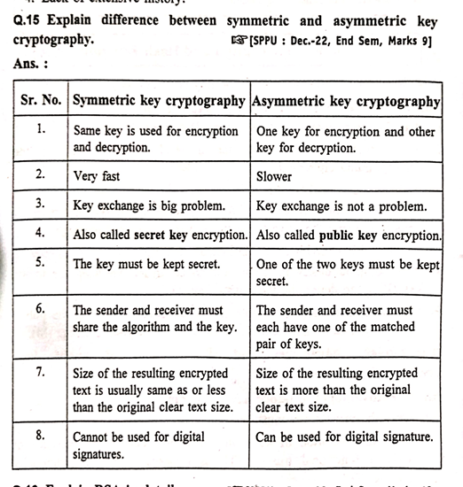

---------------------------------------------------------------**-----------------------------------------------------------------------------------------------------------------  
q12)Explain Private Key Management [9 Marks]**Private Key Management refers to the **secure creation, storage, distribution, and use of private keys** in cryptographic systems. It ensures that **only authorized entities** can access or use the private keys, which are essential for maintaining **confidentiality, integrity, and authentication** in symmetric and asymmetric cryptography.

**🔄 Key Aspects of Private Key Management  
1. Key Generation**Private keys must be generated using a **cryptographically secure random number generator**.For symmetric encryption, both sender and receiver use the same private key.For asymmetric encryption, each user has a private-public key pair.

**2. Key Distribution**Ensures the **secure sharing of private keys** between authorized parties.Can be achieved using:Secure channels (e.g., physical delivery, encrypted email).Key exchange protocols (e.g., Diffie-Hellman).Key Distribution Centers (KDCs) in symmetric systems.

**3. Key Storage**Private keys must be stored securely to prevent unauthorized access or theft.Storage options:Hardware Security Modules (HSM)Smart cards or USB tokensEncrypted software key stores protected by passwords

**4. Key Usage**Usage of private keys must be controlled:Only by authenticated users.With restrictions on usage (e.g., for encryption, decryption, or digital signing).Prevent misuse through logging and access control.

**5. Key Renewal / Rotation**Regularly update private keys to reduce risk in case of compromise.Periodic key rotation minimizes exposure if the key is leaked.

**6. Key Revocation**If a private key is compromised, it must be revoked immediately.Revocation is managed through:

* + Certificate Revocation Lists (CRLs)
  + Online Certificate Status Protocol (OCSP) for real-time verification

**7. Key Expiry and Destruction**Private keys must have an expiration date.Secure deletion techniques (e.g., overwriting) should be used for retired keys.

**🔐 Importance of Private Key Management**Prevents **unauthorized access** to confidential data.Ensures **trust and reliability** in digital communications.Helps maintain **compliance** with security standards like ISO/IEC 27001, PCI DSS, etc.

**🔒 Challenges in Private Key Management  
Key compromise risk** if not properly stored or transmitted. **Complexity** in managing multiple keys for different users and systems. **Performance overhead** when using secure hardware for key storage.  
---------------------------------------------------------------**-----------------------------------------------------------------------------------------------------------------**